

Procedure for Self-Injection

Introduction

The injection drugs used at this Clinic are only PGE₁ (Alprostadil) or the triple mixture (PGE₁, Papaverine and Phentolamine). PGE₁ and the Triple Mixture (TriMix) can only be purchased at the Toronto Western Hospital, Toronto General Hospital or Sunnybrook Hospital. Caverject (which is a single dose PGE₁) can be ordered from most pharmacies and should be ordered at least 3 days before your teaching appointment.

Triple mix must be refrigerated (not frozen). Caverject is considered a onetime use injection and does not require refrigeration. Caverject/Alprostadil should not be used more than 3 times a week, with at least 24 hours between each dose. It should never be used more than once in a 24 hour period. Never inject more than what is suggested by the doctor.

Equipment for Self-Injection
(Available from the pharmacy by prescription only)
- Syringes
- Needles
- Alcohol Swabs
- Medication Vial (Aprostadil or TriMix)

Note: Always check the expiration date on the medication bottle to make sure the date has not passed. Do not use expired medication; call your doctor for a repeat of the prescription. DO NOT USE THE MEDICATION IF IT IS CLOUDY, COLORED, OR CONTAINS PARTICLES.

Steps to Follow:

- Wash hands well with soap and water.

- Remove sterile syringe and needle from package.

- Pull cap off of needle. Do not contaminate the needle. It must only touch the inside of the cap or the rubber top of the medication vial.

- Take an alcohol swab and wipe the rubber tops of the vial.

- Hold the bottle upside down and insert the needle into the rubber stopper. Slowly pull the plunger down just a little way past your dosage. If there are no bubbles, push the plunger until the tip of the plunger is at the line which marks your exact dosage. (Figure 1)
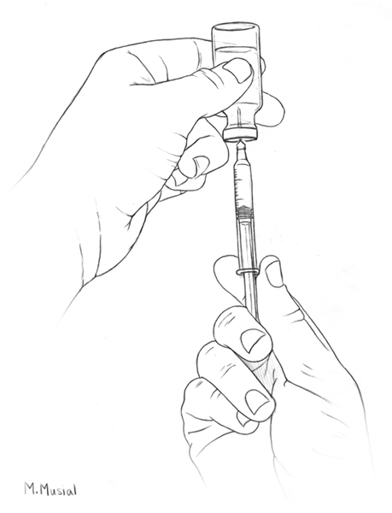
Figure 1

If there are air bubbles in the syringe, follow Step 6.

- To remove an air bubble, remove the syringe from the bottle. With the needle pointed up, flick or tap the syringe at the bubble with your finger. When the bubble goes to the top of the syringe, push the plunger tip up to your exact dose. It is important to remove the air bubble from the syringe so you will have an accurate dosage. Be accurate. Repeat step 6 if necessary.

- Carefully place the cap on the needle and place the syringe on a clean, dry, flat surface until you are ready to inject.

- Open an alcohol swab and clean the injection site on the side of the penis, close to its base (near your body).

- Remove the cap from the needle.

Injection Technique:

- Hold the penis steady with one hand. Place the thumb of this hand on the upper surface of the penis and the index finger on the lower surface of the penis and pinch the skin over to the side opposite the injection site. This makes the injection site more approachable. (Figures 2 & 3)
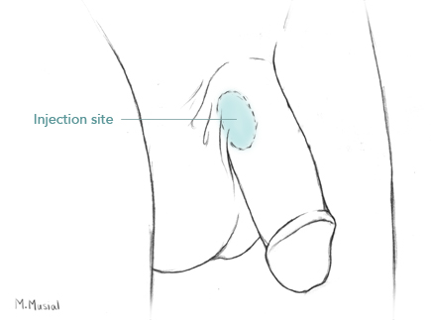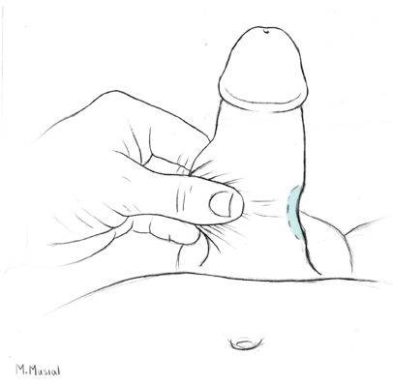
Figure 2 Figure 3

- Hold the syringe in the other hand, as you would a pencil (this is for greatest control), and insert the needle straight into the shaft of the penis at a 90 degree angle to the skin, near the base of the penis, close to the body. Make sure the needle is all the way into the penis. (Figures 4 & 5)

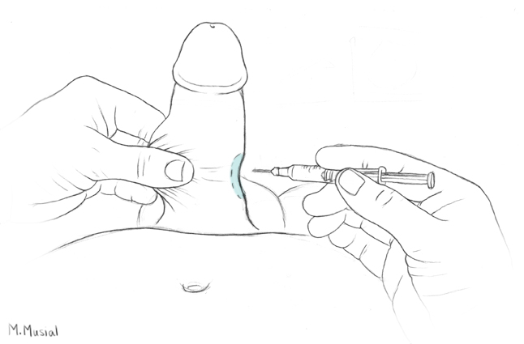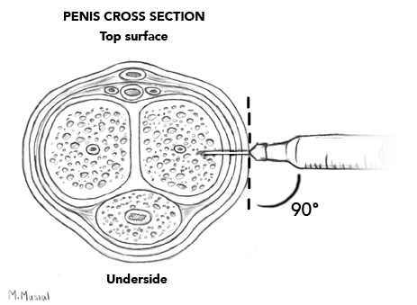

Figure 4 Figure 5

- Avoid:

  - Visible skin blood vessels.
  - Top surface of the penis (blood vessels and nerves located here)
  - Underside of the penis (urine passage is located here) (Figure 6)

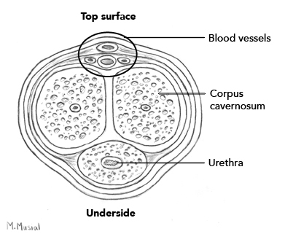
Figure 6

- Insert needle as far as it will go. You should feel a slight “give” as the needle enters the correct space inside the penis (the corpus cavernosum). You may inject into either side, as the two sides are connected.

- Push the plunger to inject the medication. The plunger should slice easily. If not, remove the needle from the penis and try steps 10 through 14 again.

- Remove the needle from the skin at the same angle it was inserted. Always apply 3-5 minutes of pressure with the alcohol swab to the needle site.

- Should you see a small amount of blood accumulating under the skin, apply steady pressure at the injection site for 10 minutes. This will help to prevent bruising.

- Carefully recap the needle securely and safely dispose of the needle, syringe and swab.

Precautions:

Medication induced erections may take 2 to 15 minutes to develop. The erection may not be rigid, but it may be improved in quality and rigidity with sexual stimulation. The average duration of erection aimed for is about one hour. This duration is dose-related. In the event that the erection lasts less than one hour, you may attempt to extend the duration the next time you use the medication (at least 24 hours after use and up to 3 times/week) by increasing the dosage by 0.1 cc (or 10 units on an insulin needle), from a starting dose of 0.25 - 0.5 cc. Further increases of 0.1 cc on subsequent attempts should be restricted to a maximum dosage that is instructed by your physician.

Prolonged erection (erection lasting over 4 hours) may occur with this treatment. In the unlikely event that this does occur, try 10-30 deep knee bends and/or apply ice to the erection. If it does not come down, you must call the doctor or go to the Emergency Department. Do not ignore a prolonged erection. Further erection difficulties could result if this problem is not dealt with promptly.

Side Effects:

Side effects may occur. These are not cause for alarm. These include:

- From errors in injection technique:

  - Bruising may take from 24 hours to 2 weeks to heal, depending on the extent of the bruising. Stop injections until bruising has cleared,
  - Blood in the urine: increase fluid intake. It usually goes away in a few hours. If not, notify your doctor,
  - Painless swelling of the penis but no increase in length or firmness. This usually goes away in 3-4 days. If not, notify your doctor.

- Pain or burning at the tip of the penis. This is called referred pain and usually subsides within 2 to 3 minutes.

Note:

The usual starting dose of Alprostadil is dependent on the cause of the Erectile Dysfunction. For blood vessel dysfunction (vasculogenic), emotional/psychological interference (psychogenic) or mixed causes, 2.5 - 5 μg (or 25 - 50 units on an insulin needle) is used initially. The starting dose for erectile dysfunction specific to nerve damage alone (neurogenic) is between 1.25 – 2.5 μg (or 12.5 - 25 units on an insulin needle) of Alprostadil. Use only what has been instructed by your doctor.

Disposal
The CAVERJECT needle and syringe should never be reused.
After injecting, throw out the used syringe right away. Put it in a special container made for used syringes and needles. It can be a hard plastic container with a screw-on cap, or a metal container with a plastic lid labeled "Used Syringes." Do not use glass or clear plastic containers.

You can get these special containers from your pharmacist. Always keep this container out of the reach of children.

